CanSat Final Report

Contents

CanSat after Recovery 3

CanSat Launch and Recovery Distance 3

Data Collected on micro SD Card 4

Conclusion 4

Acknowledgement

The journey of CanSat has been long and tedious but no doubt it was very interesting and we as participants are very delighted and happy with the opportunity provided to us through CanSat Competion organized by INSPACE. We appreciate INSPACE, ISRO & ASI for organising this event and giving us such platform to work with our friends despite being of different educational streams which showed the importance of collaboration with others of different background complimenting our lack of knowledge in those departments and helping us excel in big and complex projects involving various expertise. The most dreading thing during any competition is the attitude of the jury members and their responses to our team’s progress, we are proud to say and glad that we had some of the best jury members who evaluated our efforts accordingly and supported us in improving our Project through their guidance and gentle sweet advices which we found very motivating.

We would also like to express our gratitude towards our college for supporting us and guiding us throughout the process. Despite several obstacles faced and failures encountered we are glad that the institute still kept faith in us.

We would further like to extend our thanks to our sponsor Rudrabots for believing in us all the way to the end.

A team can not perform to its fullest unless it has got a good guidance and hence we would like to thank our mentor Dr. Abhishek Rawat for believing and guiding us through this exciting CanSat Journey.

# CanSat after Recovery

# CanSat Launch and Recovery Distance

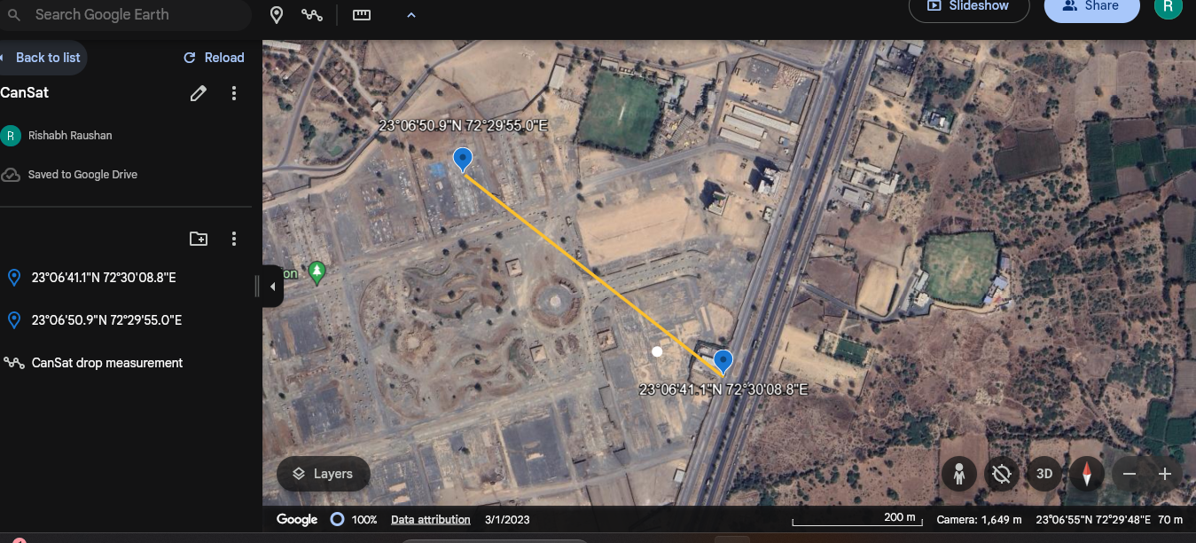

# Data Collected on micro SD Card

# Conclusion